CONCH Project
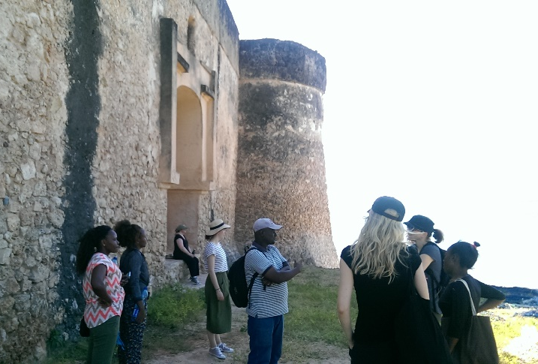
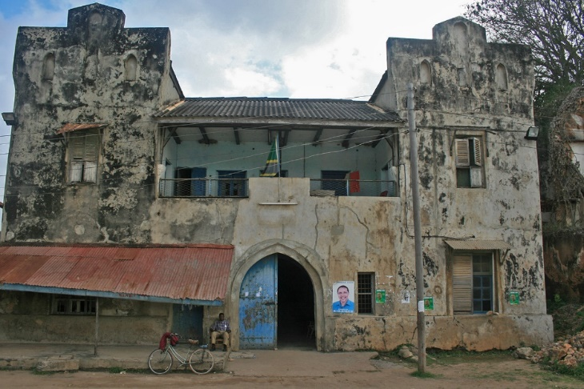
Co-production Networks for Community Heritage in Tanzania

About the project:

This project is led by the University of Dar es Salaam, University of York, Uppsala University, UZIKWASA (Pangani, Tanzania), Archaeolink (Cambridge), and also includes the Antiquities Department (Kilwa, Tanzania).
The CONCH project aims to reveal the rich heritage and history of two locations—Pangani and Kilwa—to tourists and residents. This project will raise awareness of Tanzania's cultural heritage and involve Tanzanian heritage expertise, scholars, schools, heritage organisations, and communities.
What we will be doing:
Over two summers (2018-2019), we will be carrying out workshops with scholars and local groups.
This also includes training sessions at Pangani, and Kilwa, wherein Tanzanian scholars, local groups and students will be taught techniques of mapping and documenting built spaces.

What data will we gather for our research?:

We will collect the following data for our research:
- Information and photographs about the archaeological sites we excavate;
- photographs of people involved in our workshops and field school;
- any email addresses of those who want to be involved in the project;
- Interviews with different people;
- Interactions with the project online via our Website, Facebook & Instagram pages.

What will the data be used for?:

- Information about the archaeological excavations will be used for future academic publications;
- Photographs & interview content will be circulated on our social media sites, website and future academic publications;
- Emails will be used to keep in contact with you;
- Website & social media usage by participants will be used to evaluate the project.

How will data be stored?:

During fieldwork all data will be kept temporarily within CONCH’s Cloud Drive, which is provided by Google. This means that data can be located at any of Google’s globally spread data centres, although such access is limited. For further information see, https://www.york.ac.uk/it-services/google/policy/privacy/."

After fieldwork is complete (August of 2018 & 2019) data will be moved within the University of York’s IT services secure storage area, which will only be accessible by project team and the above collaborators. At this point data will not be accessible by any third parties outside of the project. Data will be stored for 5 years and thereafter reviewed.

Confidentiality, Anonymity & Opting out:

If you agree to be involved in the project then you agree to have data collected. Emails, names and social media profiles will be kept confidential within the project team.

Qualitative information from any interviewing will be kept confidential except in the case that quotes are taken and displayed on the website. In these cases, you will be asked for your permission for your words to be presented online.

Anonymity is not guaranteed particularly as names and emails contact details will be kept in order for members of the project team to contact you--however emails and names will be destroyed after the lifetime of the project unless participants wished to be kept on the contact list.
Anonymity will not extend to the photographs shared on our social media pages, website but your profile will not be tagged and you will not be named unless you request it. Photographic copyright will be retained by partners of the CONCH project team.

You have the right to ‘opt out’ at anytime. You can request any photographs or interview content you have contributed to be destroyed. Just let a team member know at any point in the project. This extends to guardians or supervisory adults of under 18 year olds.

If you have any questions about the project please contact a member of the team, on our Facebook Page (search @conchproject) or email us on info@conchproject.org.

